PRESS RELEASE - Wednesday 18th September 2019 #EAMS19

Mental Health Industry Leaders in the Entertainment Industry attending Equity Symposium on Mental Health at Bristol Old Vic.

We do not all have the inclinations of Van Gogh!
There have throughout history been high-profile troubled creatives. Van Gogh and Sylvia Plath come to mind. There is perhaps an evocation of poetic romanticism. Disturbingly, anecdotal evidence indicates professionals outside the industry are dismissive when it comes to Entertainment Industry workers’ struggles with mental health because of this literary trope.

“The symposium is being held ahead of World Mental Health Day which is on October 10th,” says Gerard Cooke, Bristol & West General Branch’s Vice-Chair, and lead coordinator for the event.

“Since the East of Scotland Branch's 2014 Stress in the Entertainment Industry event, the launch of ArtsMinds, and Thames Variety Branch’s 2019 “It’s OK Not To Be OK” event, mental health and wellbeing issues for us working in the industry are getting a brighter-and-brighter spotlight,” says Eltjo de Vries; Bristol & West General Branch’s Chair and Branch Secretary.

The 2019 Equity #ArtsMinds Symposium is being held on October 2nd at Bristol Old Vic as an effort to bring the workers and industry leaders within the Entertainment Industry together. It’s time for one voice to catalyse the tremendous work being pioneered in the mental health and wellbeing arena within the Entertainment Industry. Mental Health is more than #MeToo

“Good mental health and wellbeing are founded on empathy, kindness, patience and understanding holistically within the workplace,” says one Equity Member who has struggled with mental wellbeing issues throughout her 40+ year career in the industry.

Equity, the trade union for UK performers and production creatives in the Entertainment Industry have funded this Bristol symposium. It is not the first time Equity Members have initiated events, written reports or demanded change. For the Bristol and West General Branch of the union who meet monthly at Bristol Old Vic, one of Bristol’s premier live theatre venues, it will not be the last.

The physical event accommodates 80, for whom lunch will be provided. There will be hosted remote video access for 10 participants or satellite locations. Connections will be allocated by the submission of an expression of interest.

Tickets to attend in person are FREE and available on Eventbrite along with an expression of interest form link to apply for remote access. http://bit.ly/eams19-ticket

Equity Arts Minds Symposium - Mental Health in the Entertainment Industry
Wednesday 2nd October
Bristol Old Vic, King Street, Bristol BS1 4ED
9.30 am - 5.00pm

Organisations taking part in the panel discussions include Equity, Playing Sane, TALK, BAPAM, Industry Minds, BECTU and Musicians’ Union.

NOTES TO THE EDITOR

Contact for comment or interview:
Gerard Cooke (lead coordinator)
E. bristol-west-general-branch@equity.org.uk
M. 0797 344 1929

Further information - Electronic Press Kit - http://bit.ly/eams19-epk

Symposium Overview
Equity's Bristol & West General Branch are hosting “Mental Health in the Entertainment Industry” in Bristol Old Vic's Coopers’ Hall on Wednesday 2nd October. The symposium will take place over a single day.

Keynote speakers Andy Moss from TUC’s UnionLearn will be talking about Mental Health First Aid (MHFA) along with Tracy Sullivan - a MHFA Trainer and a former Arts Centre Director who specialises in the arts sector. Annemarie Lewis Thomas from Musical Theatre Academy will discuss the #time4change campaign “Mental Health Charter for the Performing Arts”. There are x2 panel discussions, “Support for Mental Health and Well-being” and “Mental Health in the Workplace and in Education/Training”. The symposium concludes with an Open Space session. This is an ‘Unknown Funds’ supported event, (awarded by Council in July http://bit.ly/eams-announcement)

EVENTBRITE TICKET LINK - http://bit.ly/eams19-ticket

Photo: Bristol and West Branch standing proud with the ArtsMind Banners.

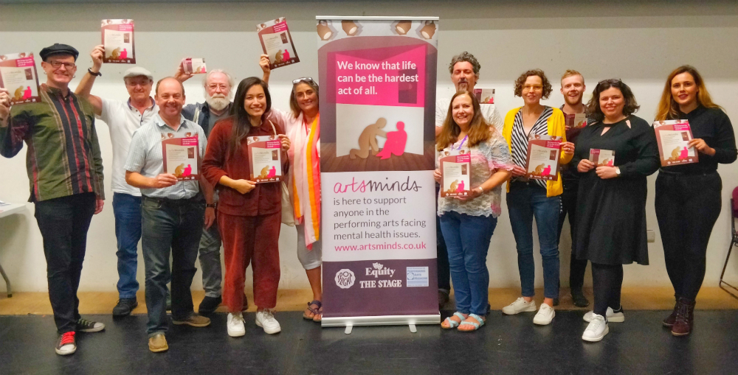

ArtsMinds
ArtsMinds is a collaboration between BAPAM, Equity, The Stage and Spotlight – four entertainment industry organisations that between us reach thousands and thousands of performers and creative practitioners working across all art forms. The trigger for the project came with a series of suicides from within our community which resulted in a call for some kind of action. The four of us came together to consider how we might support people in our creative industries who are dealing with emotional stress and mental health challenges and the result is this resource hub.

 | 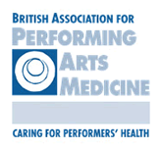
www.artsminds.co.uk | www.bapam.org.uk | www.equity.org.uk | www.thestage.co.uk | www.spotlight.com

